**MySQL: The SQL Relational Database**

MySQL is one of the widely used [SQL Database Management System](https://www.educba.com/database-management-tools/). It can be cited as one of the best RDBMS being used for the development of various web-based software applications. MySQL is relational in nature since all the data is stored in different tables and relations are established using primary keys or other keys known as foreign keys.

MySQL is a strong choice for any business that will benefit from its predefined structure and set schemas. For example, applications that require multi-row transactions - like accounting systems or systems that monitor inventory - or that run on legacy systems will thrive with the MySQL structure.

**MongoDB: The NoSQL Non-Relational Database**

A NoSQL database is a non-relational database, which provides a mechanism for storage and retrieval of data. In the NoSQL database, data is modeled in means other than the tabular relations used in relational databases.

MongoDB, on the other hand, is a good choice for businesses that have rapid growth or databases with no clear schema definitions. More specifically, if you cannot define a schema for your database, if you find yourself denormalizing data schemas, or if your schema continues to change - as is often the case with mobile apps, real-time analytics, content management systems, etc.

**For example:**

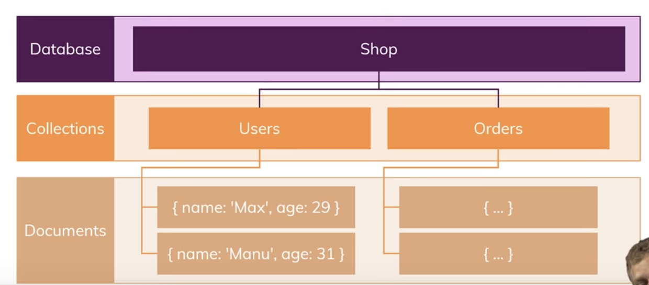

***Differences:***

Mysql:

* Data use schemas

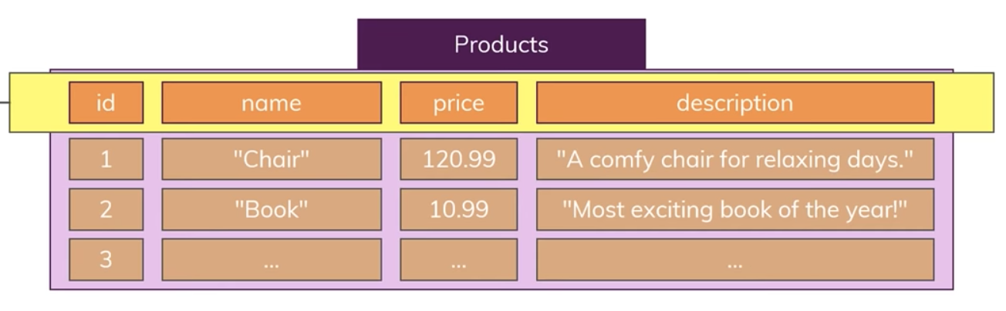

* + Disadvantage:it’s not flexible about the data
  + Advantage: It have the predictable layout
* Relations (one-to-one, one-to-many, many-to-many)

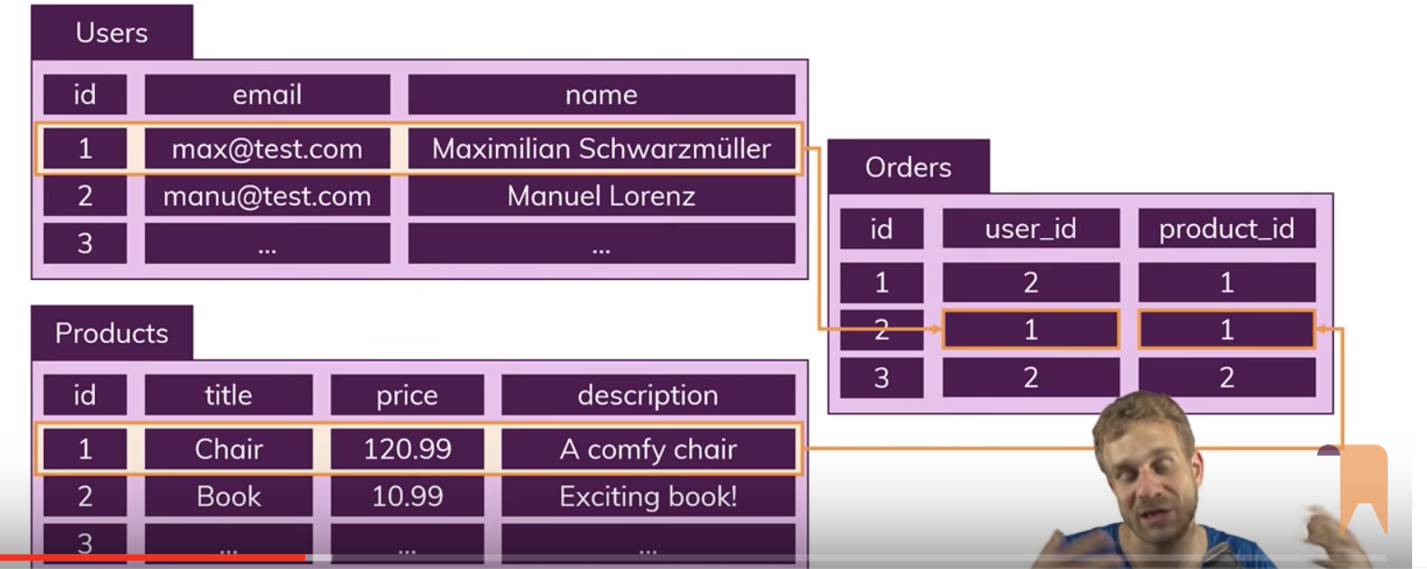

* + Advantage: The data change frequently, easier to update(only update one table, and every new query which creates orders and pulls in the table information, it will automatically take that updated data, because it only stored and managed in one place opposed to multiple places )
  + Disadvantages: if the complex queries need to do la lots of reads, which might be worse performance and
* Data is distributed across multiple tables
* Horizontal scaling is difficult/impossible(data cannot split multiple servers); vertical scaling is possible(limited by the power)

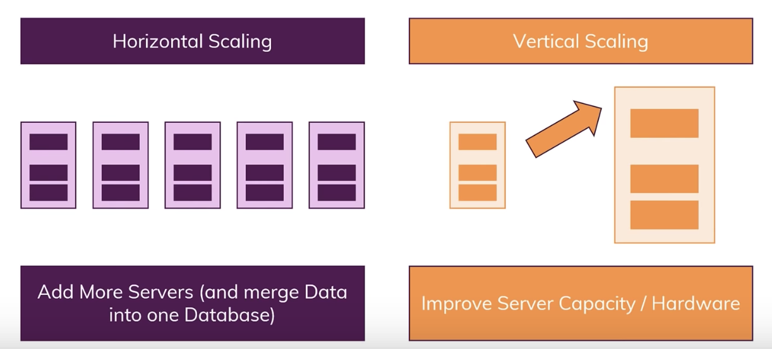

* Limitations for lots(thousands) read and write queries per second

**Nosql:**

* Schema-less/No schema

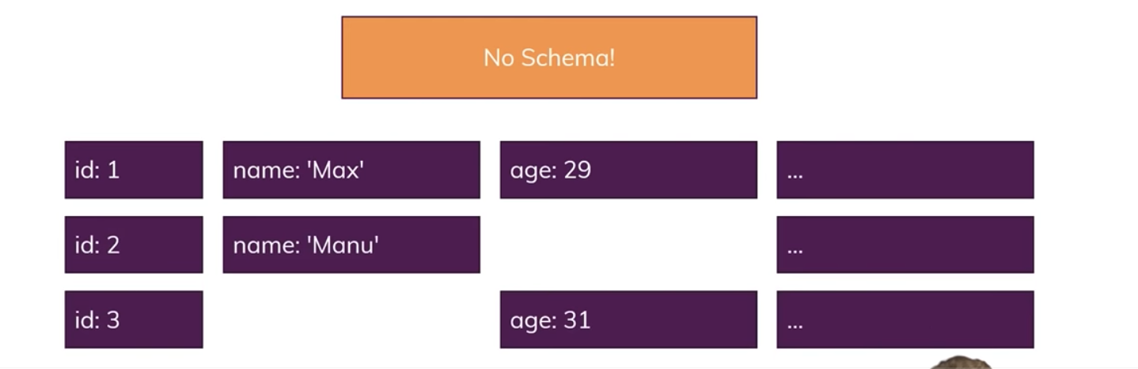

* + Advantage: more flexible
  + Disadvantage: cannot rely on the record to have certain field
* No Relations(or very few)
  + Advantages: good to read a lot
  + Disadvantages: the requests affect multiple collections, because then we have to update some data in multiple collections, because it’s duplicate instead of keep a relation.All the data already merged in right way in one collection and we don’t need to merged it manually through a query

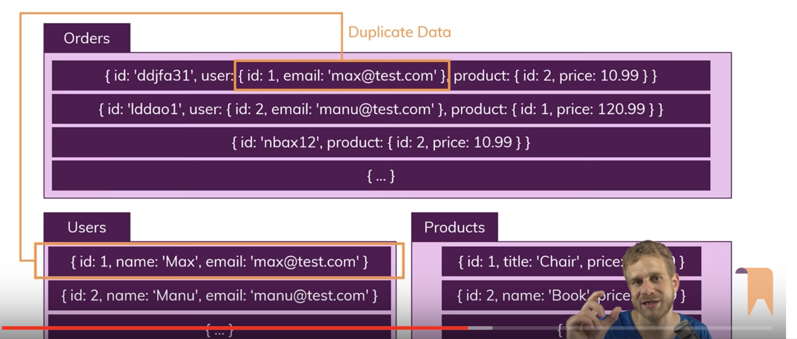

* Data is typically merged/nested in a few collections
* Both horizontal scaling and vertical scaling is possible
* Great for mass(simple), read and write requests.